Hedging Lots Strategy

- Just for simple explanation i assume that there is no spread. Take position with any directions we like, example: Buy 0.1 lot at 1.2160. At the same time or a few seconds after placing Buy, put Stop Sell 0.3 lot at 1.2130. Attentions the Lots.

TP at 1.2100
SL at 1.2100
Buy 0.1lot
at 1.2160
TP at 1.2190
Stop Sell 0.3lot at 1.2130
SL at 1.2190
30 pips
Hedging Distant
30 pips
TP
30 pips
TP
60 pips
SL
Pic:1

- If the TP at 1.2190 not reached and the price goes down and reach SL or TP at 1.2100 then we have profit 30 pips because Stop Sell has become an active Sell before.

SL at 1.2100
reached and Loss
-60 pips
TP at 1.2100
reached and Profit
30x3=90 pips
Buy 0.1lot
at 1.2160
TP at 1.2190
not reached
Sell 0.3lot
at 1.2130
SL at 1.2190
not reached
Profit90
Loss60-
30

Active
Pic:2
- But if TP and SL at 1.2100 not reached and the price goes up again, we have to had Stop Buy already at 1.2160 to anticipate. At the time Stop Sell was reached and became active Sell 0.3 lot (pic: number 2), we have to immediately place the Stop Buy 0.6 lot at 1.2160 (pic: number 3).

Buy 0.1lot
at 1.2160
TP at 1.2190
not reached
SL at 1.2100 not reached

Sell 0.3lot
at 1.2130
SL at 1.2190
not reached
TP at 1.2100
not reached
Stop Buy 0.6lot
at 1.2160
TP at 1.2190
SL at 1.2100
not reached

Pic:3

- If the price goes up and reach SL or TP at 1.2190, then we have profit 30 pips too.

SL at 1.2100 not reached

TP at 1.2100
not reached
SL at 1.2100
not reached

Buy 0.1lot
at 1.2160
TP at 1.2190
reached and Profit 30x1=30 pips

Sell 0.3lot
at 1.2130
SL at 1.2190
reached and Loss
-60x3=-180 pips

Buy 0.6lot
at 1.2160
TP at 1.2190
reached and Profit 30x6=180 pips
Profit210
Loss180-
30

Pic:4

- If the price goes down again without reaching any TP, then continue anticipating with Stop Sell 1.2 lot, then Stop Buy 2.4 lot,…and next. Continue this sequence until we meet the profit. Lots : 0.1, 0.3, 0.6, 1.2, 2.4, 4.8, 9.6, 19.2, 38.4 and 76.8.

- At this example i use 30;60;30 configuration (TP 30 pips, SL 60 pips and Hedging Distant 30 pips). Otherwise we can try use 15;30;15, 60;120;60. Also we can try to maximizing profit by testing 30;60;15 or 60;120;30 configurations.

- Considering the spread, choose the pair are most tightest spread like Euro/Usd. Usually the spread is only around 2 – 3 pips. More tight the spread, more absolute the winning we got. And I think I found the “Never Loss Strategy”…let the price move to anywhere he likes, we’ll get the profit anyway.

Actually the whole "secret" (if there is any) is to find a "time period" that the market "sure" move "enough" pips for your profit .

Regards
Harry

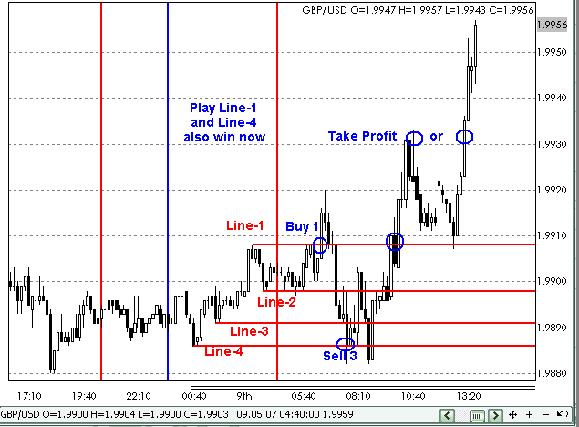

Asian Breakout using Line-1 and Line-4.
Actually you can use any range(pips) you want.
Just need to know which time period market have enough move for the pips you want.
And, one more most important thing is not to end up with buy-sell-buy-sell too many times until you run out of margin

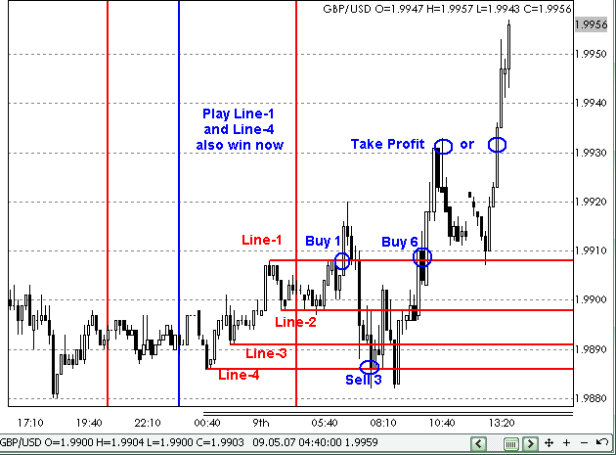

sorry, the above chart does mark up the last trade "Buy-6",

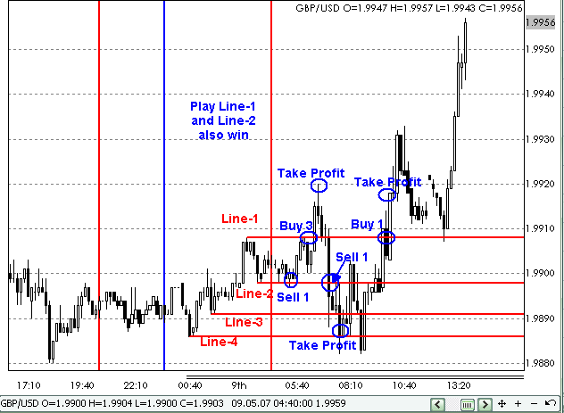

play Line-1 and Line-2 (10 pips) also win.

don't be confused, my method mentioned is very simple, only 2 things:

1. just choose 2 prices levels (H, L, you decide) at certain time(you decide), if breakout H then buy, if breakout L then sell. TP=SL=(H-L).

2. every time when lost, increase the buy/sell lots in this number sequence: 1, 3, 6, 12, 24..., If your time and price range choose correctly, you should not need so many trades.

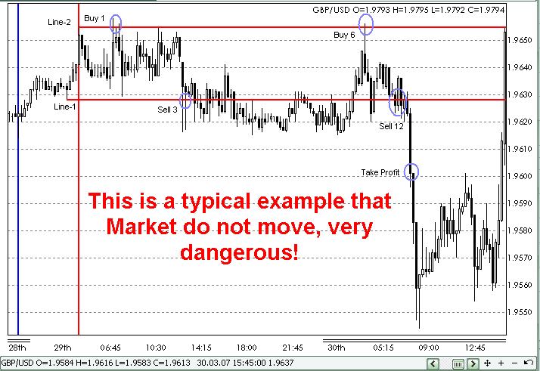

29 Mar 2007 is a typical example of dangerous day because market did not move much.
I am still thinking of how to overcome this, may be all of you can help.

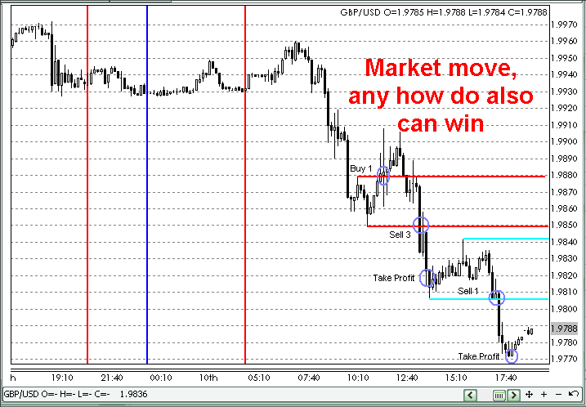

market move, any how do also can win.

Don't ask me how to set the range, any how also can win, as long as market move. If market don't move that's the END!

Additional Explanation:
Mode-1 = Start From : “ BUY ”

Take Position | Scenario | Profits/Loss
Buy-1  Lots -1 =0,1  Target -1 =50 pips  Stops -1 =100 pips | Open Position At Price  As you like (no indicator)
If Buy-1 Touch Target | Buy-1 (+50 pips) *0,1 lot | Buy-1 = $50
Open Sell-1  Lots -2 =0,3  Target -2 =50 pips  Stops =100 pips | If Buy-1 (-50 pips)
If Sell-1 Touch Target | Buy-1 (-100 pips) *0,1 lot  Sell-1 (+50 pips) *0,3 lot | Buy-1 = - $100  Sell-1 = +$150  Profit Totals = +$50
Open Buy-2  Lots =0,6  Target =50 pips  Stops =100 pips | If Sell-1 (-50 pips)  If Buy-1 (0 pips)
If Buy-1 Touch Target  If Buy-2 Touch Target | Buy-1 (+50 pips)*0.1 lot  Sell-1 (-100 pips) *0,3 lot  Buy-2 (+50 pips) *0,6 lot | Buy-1 = + $50  Sell-1 = -$300  Buy-2 = +$300  Profit Totals = +$50
Open Sell-2  Lots =1,2  Target =50 pips  Stops =100 pips | If Buy-1 (-50 pips)  If Buy-2 (-50 pips)
If Sell-1 Touch Target  If Sell-2 Touch Target | Buy-1 (-100 pips)*0.1 lot  Sell-1 (+50 pips) *0,3 lot  Buy-2 (-100 pips) *0,6 lot  Sell-2 (+50 pips) *1,2 lot | Buy-1 = - $100  Sell-1 = + $150  Buy-2 = - $600  Sell-2 = +$600  Profit Totals = +$50

Pips Step 50, Target = 50, Stop Loss =100……Safe Area = 50 pips

